**Report**

Assignment 2 - MySQL

The report does not have to be longer than 1-2 pages, excluding screenshots/images.

**Group**: 37

**Students**: Vladislav Levitin

**Introduction**

Briefly explain the task and the problems you have solved. How did you work as a group? If you used Git, a link to the repository would be nice.

The assignment consisted of two parts, first part was cleaning and inserting the Geolife dataset into a MySQL database and the second part was answering a set of questions by writing a Python program using MySQL-queries. The code for part 1 is in part1_create_tables.py and part1_insert_data.py files and the code for part 2 is located in part2.py file.

The assignment is uploaded to a GitHub repository:

**Results**

**Part 1**

User Table - first 10 rows

Activity Table - first 10 rows

TrackPoint Table - first 10 rows

**Part 2**

2.1: How many users, activities and trackpoints are there in the dataset (after it is

inserted into the database).

2.2: Find the average number of activities per user.

2.3: Find the top 20 users with the highest number of activities.

2.4: Find all users who have taken a taxi.

2.5: Find all types of transportation modes and count how many activities that are

tagged with these transportation mode labels. Do not count the rows where

the mode is null

2.6

1. Find the year with the most activities.

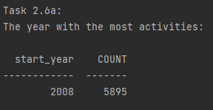

1. Is this also the year with most recorded hours?

TIMESTAMPDIFF in MySQL does only consider full hours (does not round up).

2009 was the year with the most recorded full hours. 126% more minutes than 2008 and 132% more full hours.

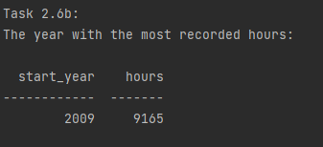

2.7: Find the total distance (in km) walked in 2008, by user with id=112.

In this task I shifted the lat and lon column so that each row had a start and end position. Then I calculated the distance for each set of points using haversine and then added up.

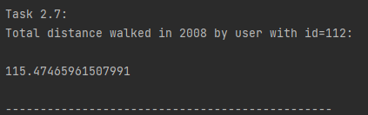

2.8: Find the top 20 users who have gained the most altitude meters.

2.9: Find all users who have invalid activities, and the number of invalid activities

per user.

2.10: Find the users who have tracked an activity in the Forbidden City of Beijing.

2.11: Find all users who have registered transportation_mode and their most used

transportation_mode.

**Discussion**

Discuss your solutions. Did you do anything differently than how it was explained in the assignment sheet, in that case why and how did that work? Were there any pain points or problems? What did you learn from this assignment?

My solution followed the assignment description.